FINANCIAL ASSISTANCE SUMMARY

Driscoll Children’s Hospital works to deliver compassionate, high- quality, affordable health care services to its patients. Financial assistance is available to eligible patients and families that are uninsured, underinsured, ineligible for a government program, or otherwise unable to pay for medically necessary care based on their Financial situation.
Driscoll Children’s Hospital financial assistance policy provides detailed information about the process for obtaining financial assistance, the eligibility criteria, and the types of assistance available. You can obtain free copies of the policy and a financial
evaluation form through any of the sources below in the HOW TO APPLY section.

Who is eligible?
All patients are eligible to apply for financial assistance, including those with insurance.
We use established guidelines to determine who qualifies and the amount of their discount.
- Uninsured or under-insured patients with family income at or below 500% of the Federal Poverty Guidelines, FPG, will receive a 100% charity discount off billed or allowed charges.
- Uninsured or under-insured patients with family income of more than 501% of FPG, may be eligible for a charity discount of 45%, 55%, 65% or 75% off billed or allowed charges.
A person who is eligible for financial assistance will never be charged more for emergency or other medically necessary care than the amounts generally billed to individuals with insurance.
For amounts generally billed [AGB], Driscoll Children’s Hospital will use the look back method as defined by the Internal Revenue Code Section 501r. Driscoll Children’s Hospital (DCH) calculates AGB using the “look-back” method as defined in section 1.501(r)-5(b)(3) by: i) identifying all claims allowed (including patient share) by Medicare, Medicaid, and all private insurance payers that pay claims to DCH in a 12 month period; and ii) dividing that amount by the gross charges associated with those claims. This AGB percentage is calculated on an annual basis. For the 12-month period ending 8/31/2022, the AGB percentage used is 32%; patients meeting Driscoll Children’s Hospital Financial Assistance policy requirements will be charged no more than 25% of the amount generally billed.
The detail of this information is available upon request by calling the financial counseling office at (361) 694-4758.

How to apply
You can apply for financial assistance by completing a financial evaluation form and mailing it to Driscoll Children’s Hospital, 3533 S. Alameda Street, Corpus Christi, TX 78411, or emailing it to driscollfinanceassistance@dchstx.org Financial Counselors are also available to assist you with the application process in the Admitting Department or by calling (361) 694-4758 or (361) 694-5163.

In Person: Admitting or Emergency Registration Office

Online: http://www.driscollchildrens.org/patient-services/charity-care
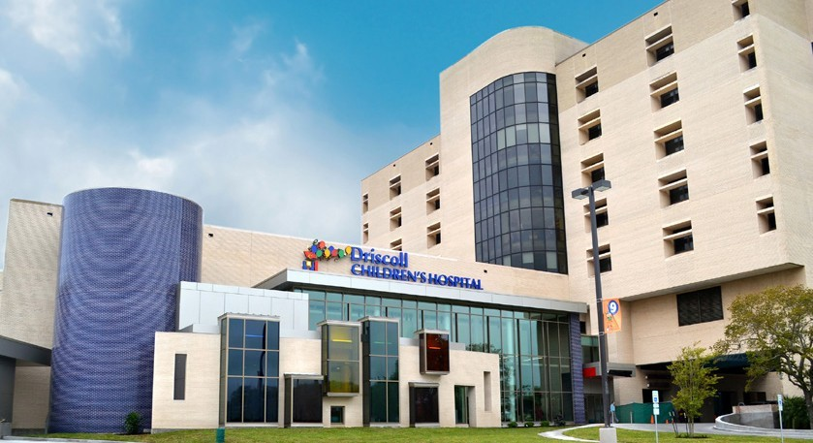
By Mail: Driscoll Children’s Hospital, 3533 S. Alameda Street, Corpus Christi, TX 78411 By Phone: (361) 694-4758 or (361) 694-5163

